Comparison of several methods for analysis of simple undamped pendulum

|  |  |
| --- | --- |
| Input parameters  Gravitational acceleration (m/s²) -  Pendulum length -  Pendulum mass -  Initial angle -  Maximum simulation time -  Analytical solution for small rotations  ≪ 1 or **sin**() ≈ |  |

Differential equation -

Angular frequency -

Cyclic frequency -

Period -

Equation of motion -

Analytical solution for large rotations (exact)

Differential equation -

Incomplete elliptic integral of the first kind

Jacobi elliptic functions

Modulus -

,

,

Period -

Error -

Cyclic frequency -

Angular frequency -

Equation of motion -

Energy -

Relative error [%] of small displacements period versus initial angle [°] plot

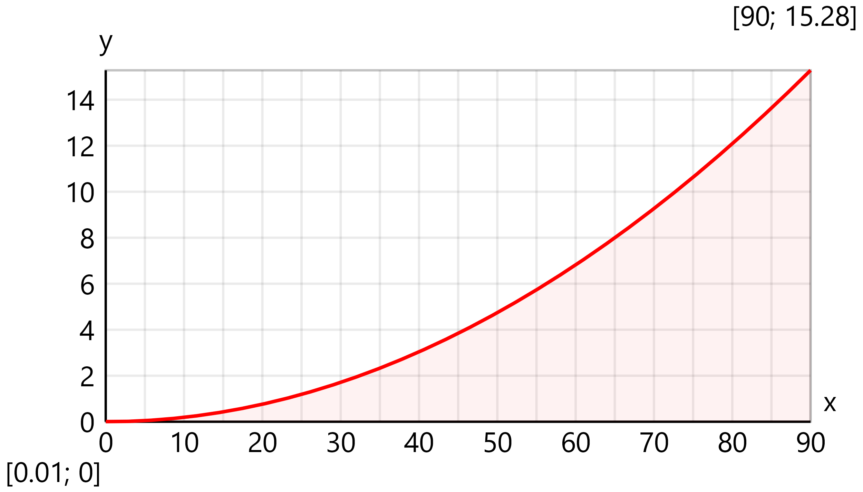

Solution by forward Euler method (explicit)

For that purpose, the II order equation is reduced to the following system of I order equations

and

The solution is performed iteratively

Step size - Number of steps -

For each time step the values for the next step will be obtained by using the following equstions

n+1 =  n + · n

n+1 =  n + · **sin** n

Allocate vectors

Set initial conditions

,

Perform Euler steps

Rotation -

Angular velocity -

Energy -

Solution by backward Euler method (implicit)

The following iterative procedure is applied:

n+1 =  n + · n+1

n+1 =  n + · **sin** n+1

Allocate vectors

Set initial conditions

,

Perform Euler steps

Rotation -

Angular velocity -

Energy -

Solution by Crank–Nicolson method (IMEX)

The following iterative procedure is applied:

n+1 =  n + (  n +  n+1 )

n+1 =  n + ( **sin** n + **sin** n+1 )

Allocate vectors

Set initial conditions

,

Perform Euler steps

Rotation -

Angular velocity -

Energy -

Solution by Runge-Kutta RK4 method (explicit)

The following iterative procedure is applied:

|  |  |  |
| --- | --- | --- |
| First step (k₁) - | , |  |
| Second step (k₂) - | , |  |
| Third step (k₃) - | , |  |
| Fourth step (k₄) - | , |  |

Update values using weighted averages

n+1 =

n+1 =

**Allocate vectors**

**Set initial conditions**

,

**Perform Runge-Kutta 4 steps**

RK4 factors

,

**Update values using weighted averages**

Rotation -

Angular velocity -

Energy -

Plot results

|  |  |
| --- | --- |
| Rotation *θ* [deg] versus time *t* [s] plot | **━━━━** Small rotations **━━━━** Large rotations **· · · · · ·**Forward Euler **━ ━ ━** Backward Euler **━ · ━ ·** Crank–Nicolson |

Energy *E* [J] versus time *t* [s] plot

Comparision of Crank–Nicolson and Runge-Kutta 4 methods

Rotation *θ* [deg] versus time *t* [s] plot

|  |  |
| --- | --- |
|  | **━━━━** Theoretical (large rot.) **━ ━ ━** Crank–Nicolson (IMEX) **· · · · · ·** Runge-Kutta 4 (explicit) |

Absolute error Δθ [°] versus time *t* [s] plot

|  |  |
| --- | --- |
|  | **━━━━** Crank–Nicolson (IMEX) **━ ━ ━** Runge-Kutta 4 (explicit) |

Energy *E* [J] versus time *t* [s] plot

|  |  |
| --- | --- |
|  | **━━━━** Theoretical (large rot.) **━ ━ ━** Crank–Nicolson (IMEX) **· · · · · ·** Runge-Kutta 4 (explicit) |